Computer Vision Homework 2

Name: 黃新予

Student ID: f08922136

1. **Environment Setup  
   Language: Python 3 (on jupyter)  
   Library: numpy, PIL, matplotlib**   
   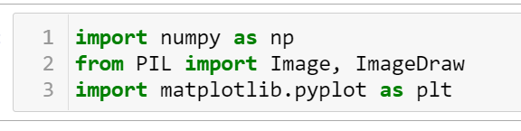
2. **Q1: binary image (threshold at 128)  
     
   Step 1: Read image into np array  
   Step 2: traverse all the element in array and filter by threshold 128  
     
   output image:**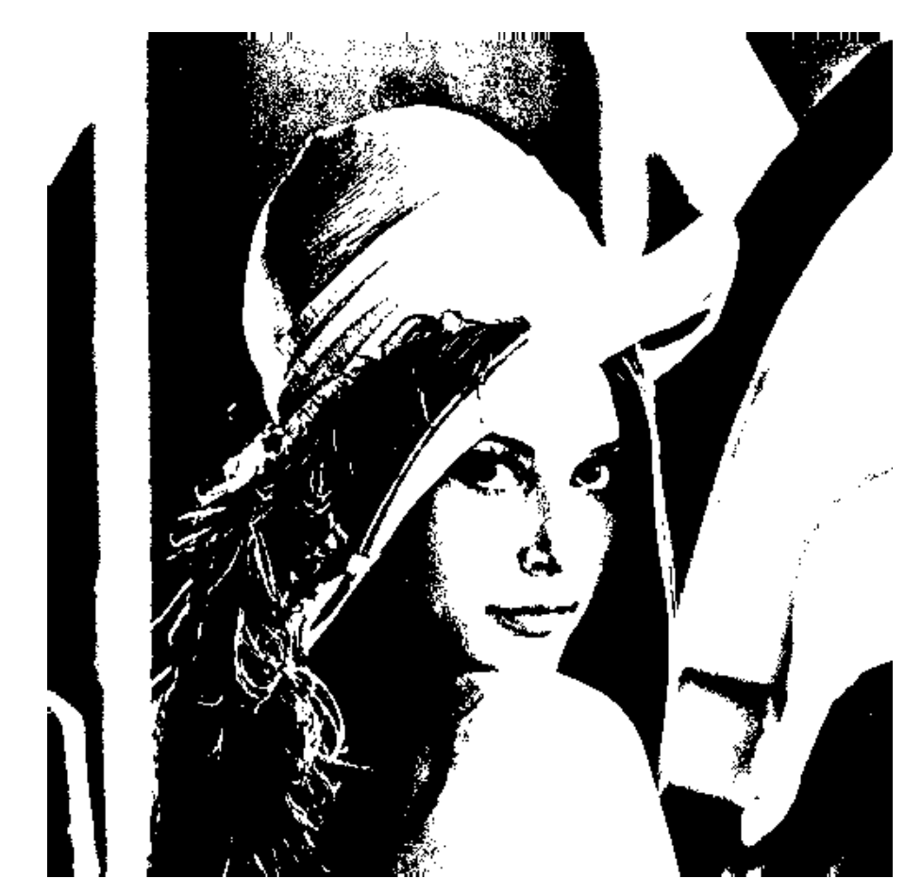  
   **code:**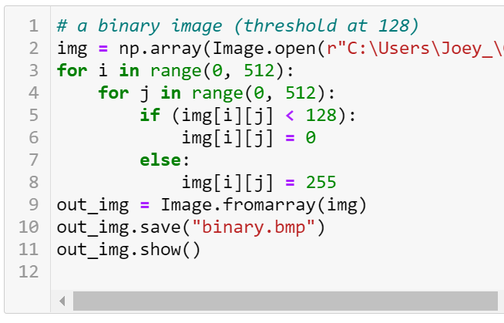
3. **Q2: create a histogram  
     
   Step 1: read image as np array  
   Step 2: traverse all the element in np array and count the number  
   Step 3: use pyplot to draw histogram  
     
   output image and code:**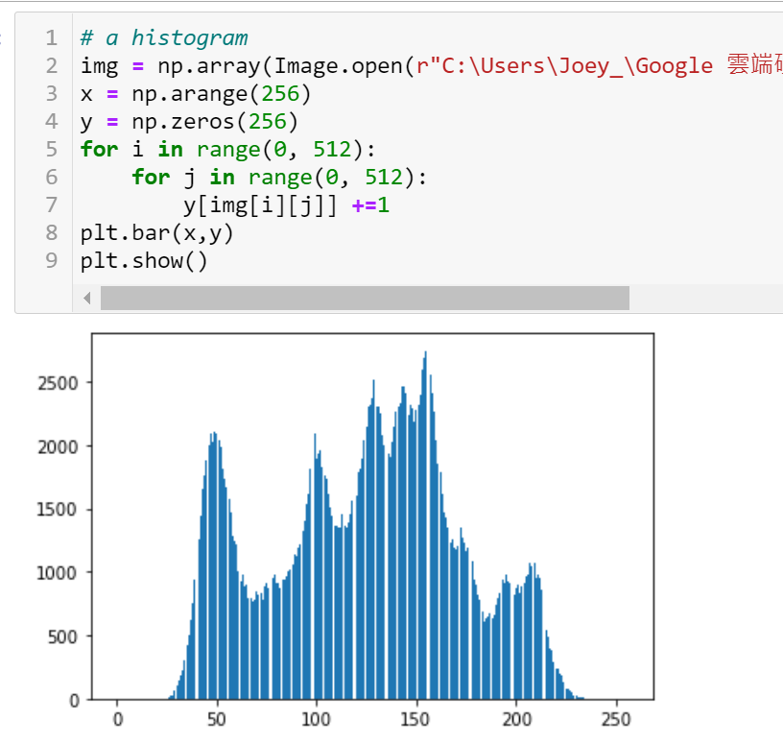
4. **Q3: connected components (regions with + at centroid, bounding box)**Ref: <https://github.com/JasonYao81000/CV2017Fall>  
     
   **output image:**  
   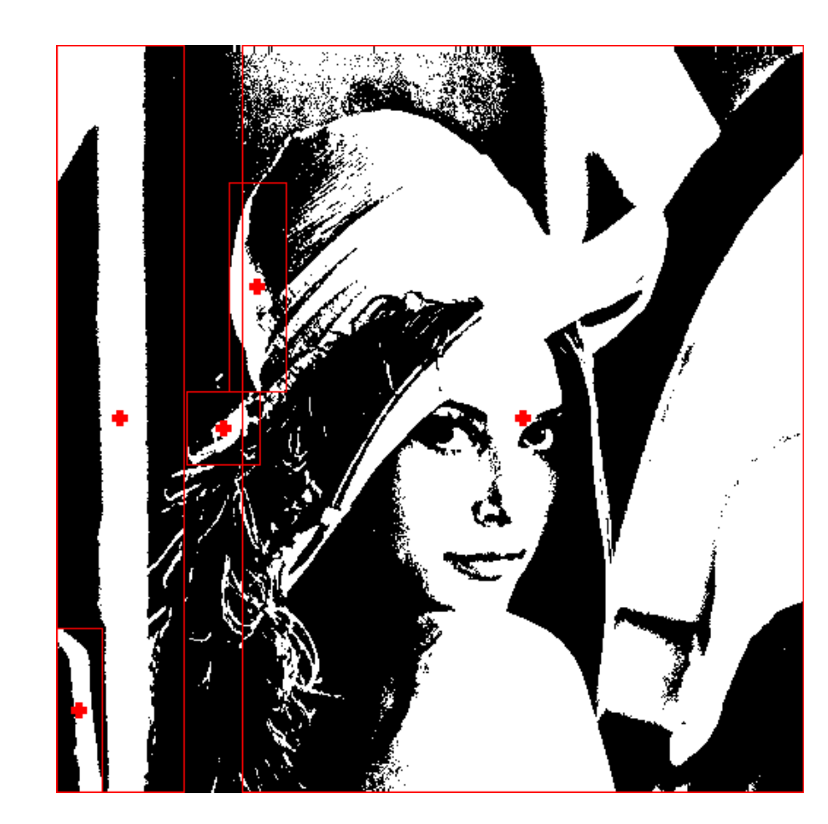  
   Step 1: read image and set up parameter  
   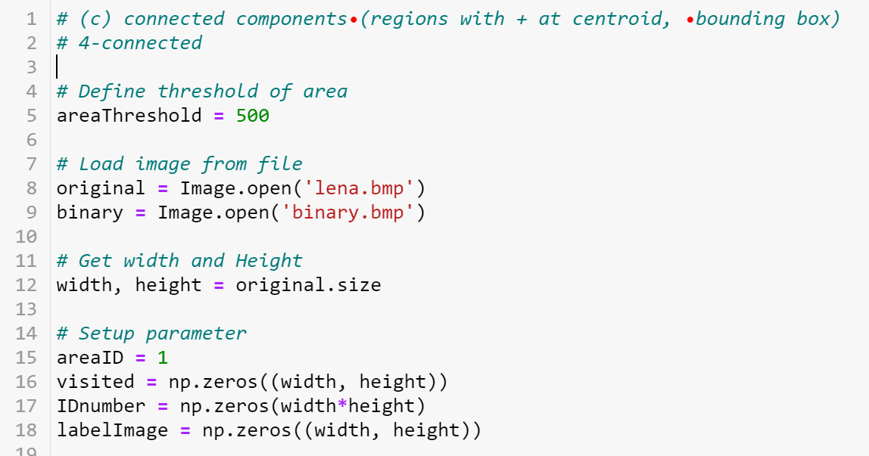  
   **Step 2: using DFS in each pixel to get connected component  
   Step 3: compare neighbor and get 4-connected component**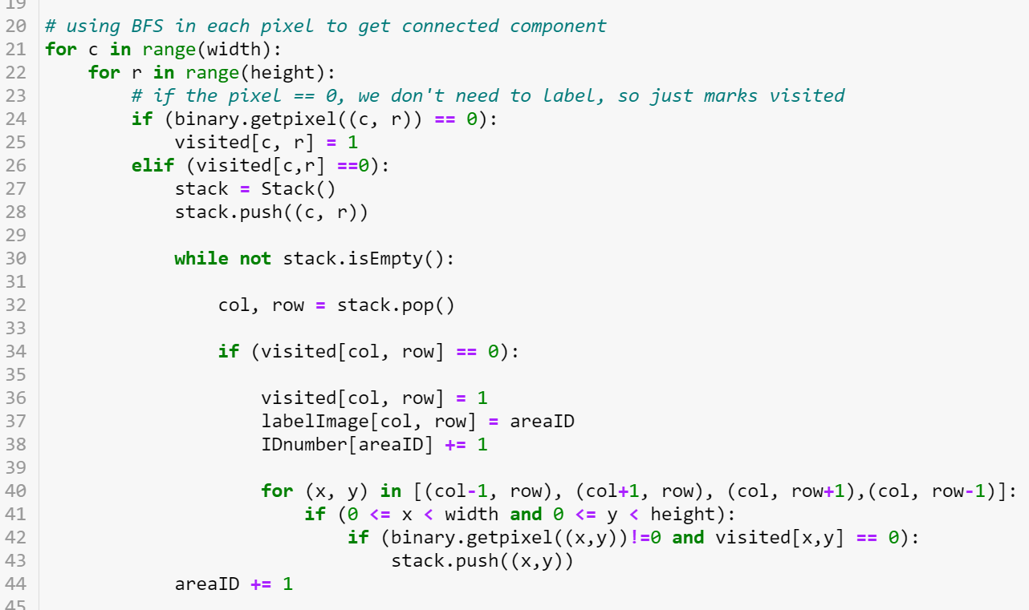  
   **Step 4: get left, right, top, bottom side of each connected component which area is larger than 500.**  
   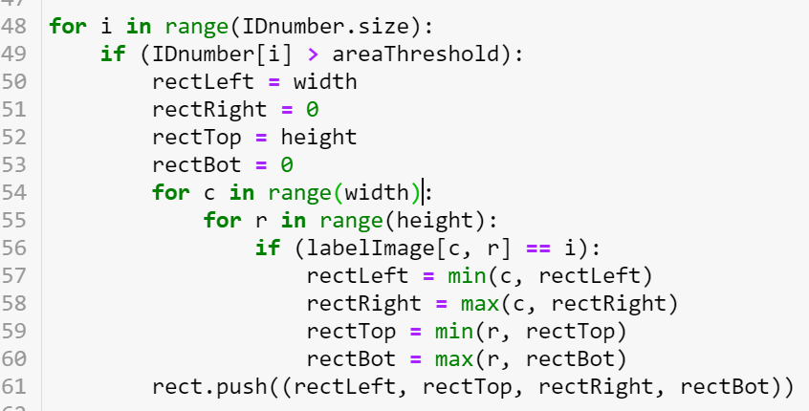  
   **Step 5: draw rectangle and cross.**